VARIABLES :

x, y, z = "Orange", "Banana", "Cherry"  
print(x)  
print(y)  
print(z)

x = y = z = "Orange"  
print(x)  
print(y)  
print(z)

fruits = ["apple", "banana", "cherry"]  
x, y, z = fruits  
print(x)  
print(y)  
print(z)

GLOBAL VARIABLES:

x = "awesome"  
  
def myfunc():  
  print("Python is " + x)  
  
myfunc()

-----------------------------

x = "awesome"  
  
def myfunc():  
  x = "fantastic"  
  print("Python is " + x)  
  
myfunc()  
  
print("Python is " + x)

O/P:

Python is fantastic  
Python is awesome

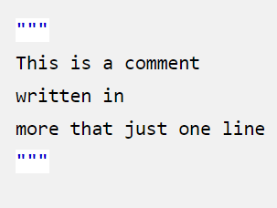

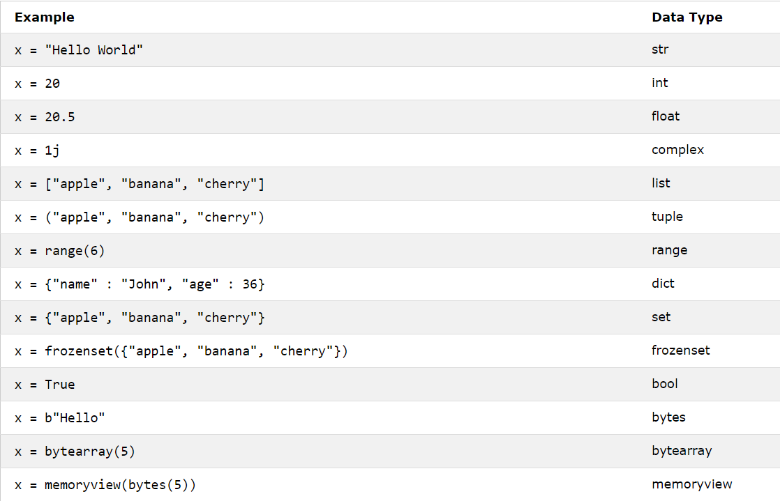

for x in "banana":

print(x)

b  
a  
n  
a  
n  
a

txt = "The best things in life are free!"

print("free" in txt)

True

